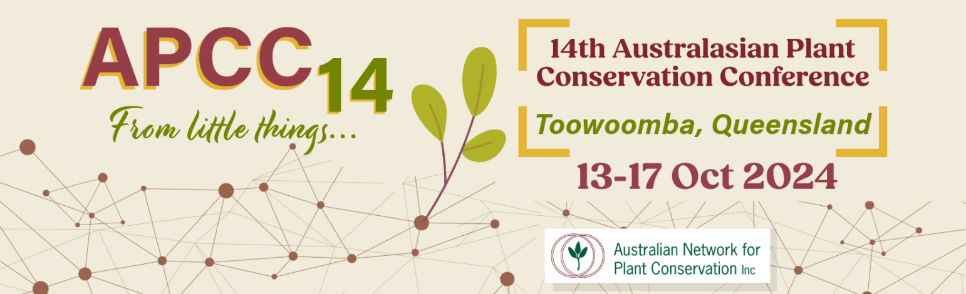

Abstract submission form – due 19 July 2024
Please use this form to submit an abstract for a conference presentation or poster.
To complete the form: type details in the boxes, save, print for your records, then send by email
to business@anpc.asn.au. Alternatively post the completed form to the ANPC contact details listed below.

PRESENTER DETAILS

Title First Name Surname
Current Position Organisation

Co-author(s)
PO Box/Street address
Suburb/Town State Postcode
Daytime phone Mobile Email
Presenter’s biography (maximum 40 words)

ABSTRACT SUBMISSION

Presentation (or) Poster
I would like my abstract to be considered for the following plenary theme(s) (please tick):

Northern Connections

Living on the Edge

Navigating Natural Disasters

Fighting Feral Pathogens
No theme

For more details on the Plenary Themes please refer to our website https://www.anpc.asn.au/conferences-apcc14/

Note: Presenters will be allocated 15 minutes in the Conference Program for their presentation. 10 minutes will be allocated for questions to all presenters at the end of each session.

Tick here if you are prepared to submit a full-length paper (approx. 1200 words) for publication in Australasian Plant Conservation (you will be contacted by the editor prior to the conference). The deadline for this is 1 November 2024. Email editor@anpc.asn.au for any queries about submission of full-length papers.
Proposed title of presentation / poster:

Abstract (maximum 250 words):

Note: Please submit abstracts via email to business@anpc.asn.au by Friday 19 July 2024.
Abstracts should be no more than 250 words in length.
All abstracts will be made available online for download by conference participants.

Australian Network for Plant Conservation Inc.
GPO Box 1777, Canberra, ACT, 2601, Australia

Telephone: +61 (02) 6250 9509
Email: business@anpc.asn.au
Web: www.anpc.asn.au

Supported by the Queensland Government Department of Environment, Science and Innovation

