12th Australasian Plant Conservation Conference

“Moving House – A New Age for Plant Translocation and Restoration”
11 - 15 November 2018, Canberra

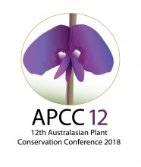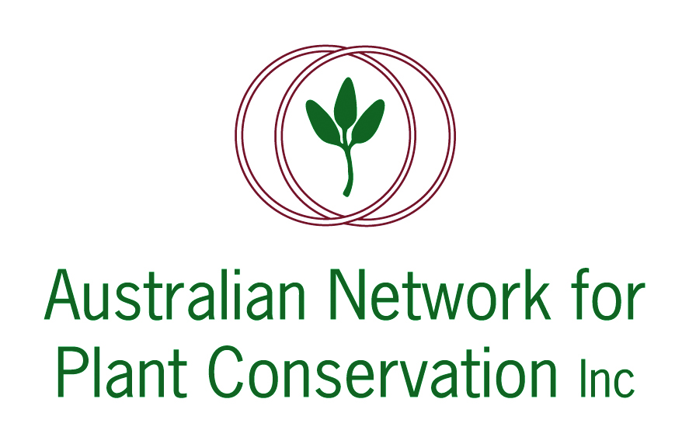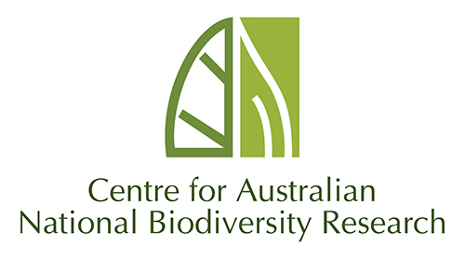

ABSTRACT: PLENARY LECTURE 2

‘Plant conservation actions and comparative ecology: But we don’t know enough!’
Dr Peter Vesk
University of Melbourne
Roughly 300,000 species of seed plants exist in the world. We have good ecological knowledge about relatively few of them and know much less about most. The ability to generalise knowledge from one situation to another is a central feature of science. Moreover, generalisation is crucial to conservation and ecological management when we wish to manage species with little direct recorded knowledge. In this talk I will discuss the challenges of learning fast and effectively in order to do conservation well. I will describe how my colleagues and I have been working through the problem of generalising ecological knowledge and in particular the use of statistical models for species responses involving species traits. I will draw on case studies of species distribution, growth responses after fire, and urbanisation.

